 SCHOOL OF COMPUTING
DEPARTMENT OF SOFTWARE ENGINEERING, INFORMATION TECHNOLOGY, COMPUTER SCIENCE AND ENGINEERING
FACULTY OF ENGINEERING & TECHNOLOGY

MINI PROJECT REPORT

SUBJECT TITLE: OBJECT ORIENTED ANALYSIS AND DESIGN
SUBJECT CODE: 15SE203
PROJECT TITLE: PayTM

By
Aditya Jyoti Paul
RA1711003010572

Dept. of Computer Science and Engineering

SRM Institute of Science and Technology
SRM Nagar, Kattankulathur-603203
Kancheepuram District, Tamil Nadu

Experiment Component | Max. Marks | Grading Rubrics
Documentation/  Procedure | 3 | UML Diagram’s are well documented. The documentation supporting all functional requirement and non-functional requirement(3) |  | Missing two or more required functional requirement .The documentation work not up to the mark. (2)
Concept  Diagrams and Usage of Symbols  Static Diagrams, Dynamic Diagrams | 4 | Completeness of concept, consistent variable naming and relationship in static view. Precise usage of symbols in dynamic view.(4 Marks) | Completeness of concept, inconsistent variable naming and relationship in static view. (3 Marks) |  | Incomplete static view. (1 Mark)
Concept  Diagrams and Usage of Symbols  Dynamic Diagrams  State Chart and Activity | 3 | Precise usage of symbols in dynamic view.  All States and Activities Recognized and flow described  (3 Marks) | Incorrect/omitted states and activities.  (2 Marks) |  | Symbol’s misplaced in diagram.  (1 Mark)
TOTAL | 10

List of Diagrams
S.No | Diagram Name | Page No
1 | Use Case Diagram | 5
2 | Class Diagram | 6
3 | Sequence Diagram | 7
4 | Package Diagram | 8
5 | Collaboration Diagram | 9
6 | State Chart Diagram | 10
7 | Activity Diagram | 11
8 | Component Diagram | 12
9 | Deployment Diagram | 12

15SE203-OOAD-Mini Project(Rubrics) |  |  |  |  | Title:
 | 1 | 2 |  | 3 |  | 4 | Total
Application Components | Concept [2] | Usage of Symbols[4] |  | Diagram and Layout [2] |  | Innovative ideas[2] | 10
Marks awarded
Staff Signature |  |  |  |  |  | Total Marks (Max = 10)

1. | Name of the Project | PayTM
2. | Objective/ Vision | Paytm is an Indian e-commerce payment system and digital wallet company. To maintain a web based intranet application and an app that enables the use of the e-wallet in a smooth and sophisticated fashion
3. | Users of the system | - Admin  - Users
4. | Functional Requirements | - A system where the user can enter personal details like name, bank details  - Easy transfer of money from one user to another  - Easy transfer from user to bank  - Users should be able to see past transactions and raise an issue with customer care in case of any error.
5. | Non-functional requirements | - Secure access of confidential data  - 24 X 7 availability  - Flexible service based architecture will be highly desirable for future extension
6. | Optional features | - Sending gift cards  - Buying movie tickets  - Online seller platform
7. | Team Size | 40-50
8. | Technologies to be used | Java, NodeJS, Android Studio,
9. | Tools to be used | - Visual Paradigm Tool  - NetBeans IDE
10. | Final deliverable must include | Documentation Report

UML Diagrams
- Use Case Diagram
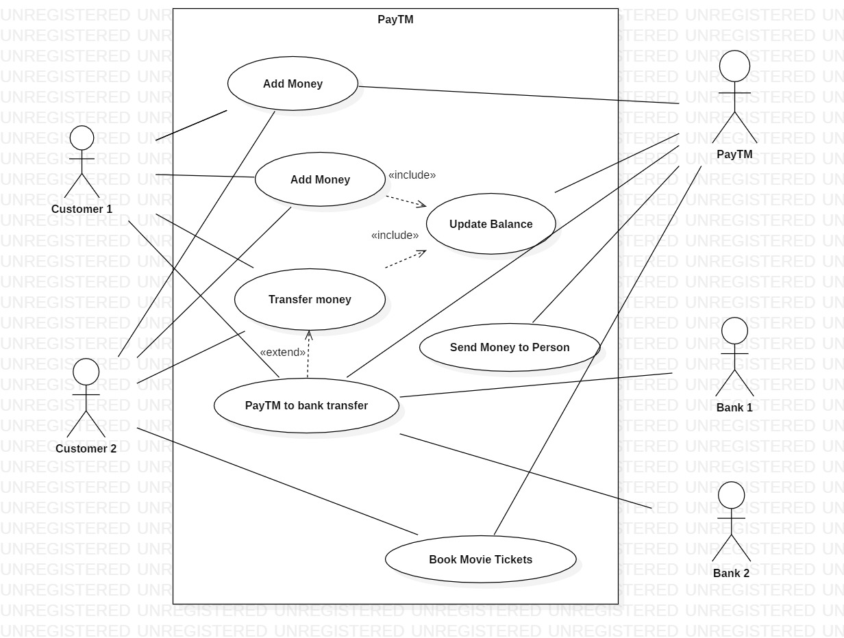

- Class Diagram

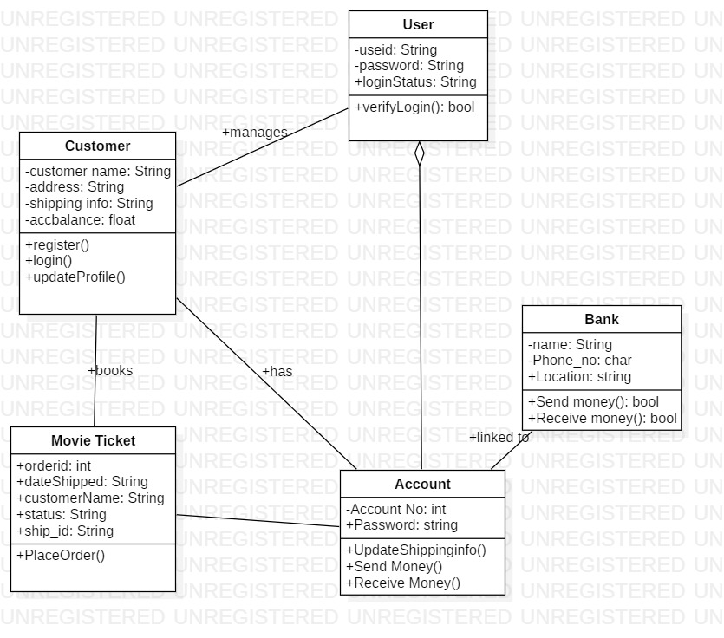

- Sequence Diagram
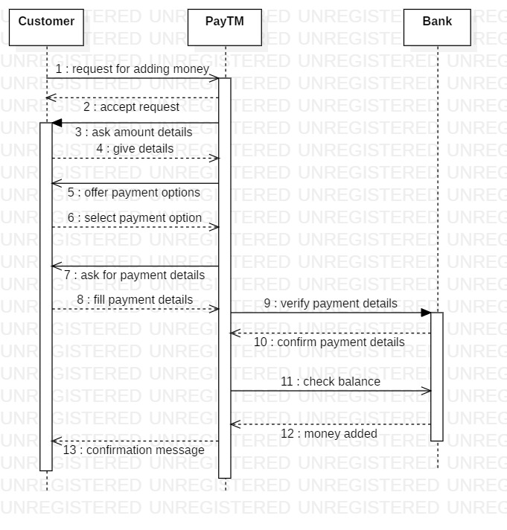

- Communication Diagram
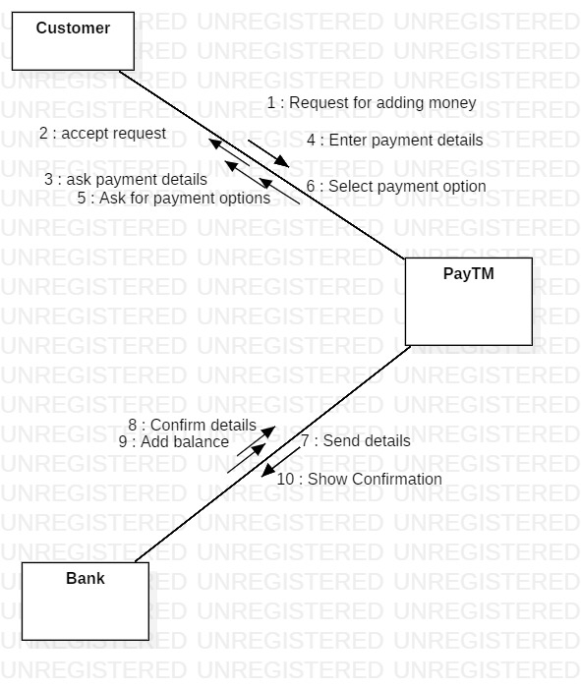

- Package Diagram
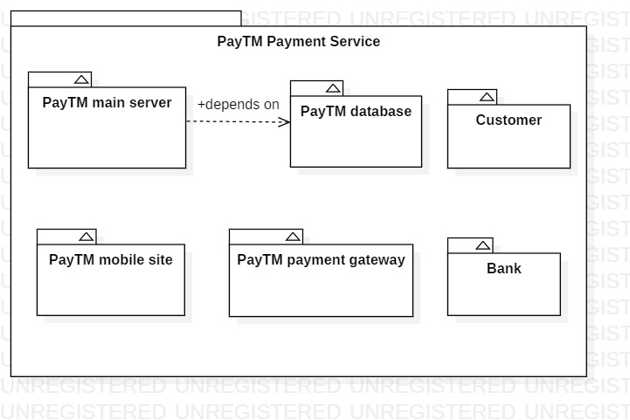

- Start Chart Diagram 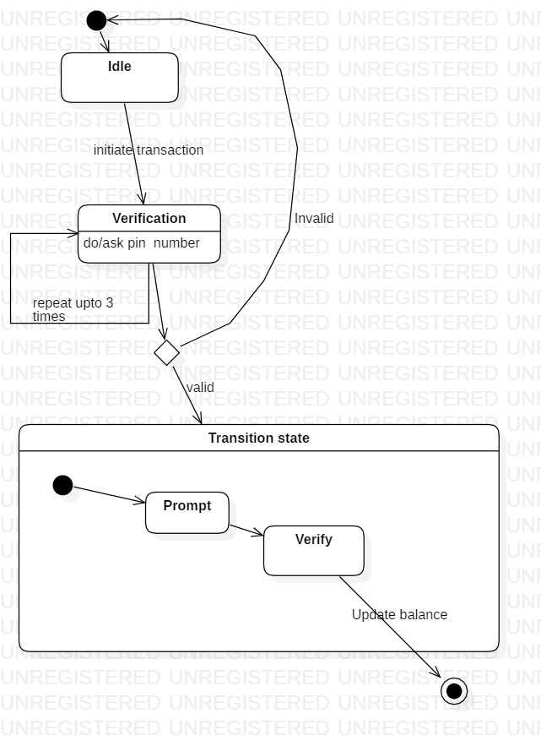

- Activity Diagram

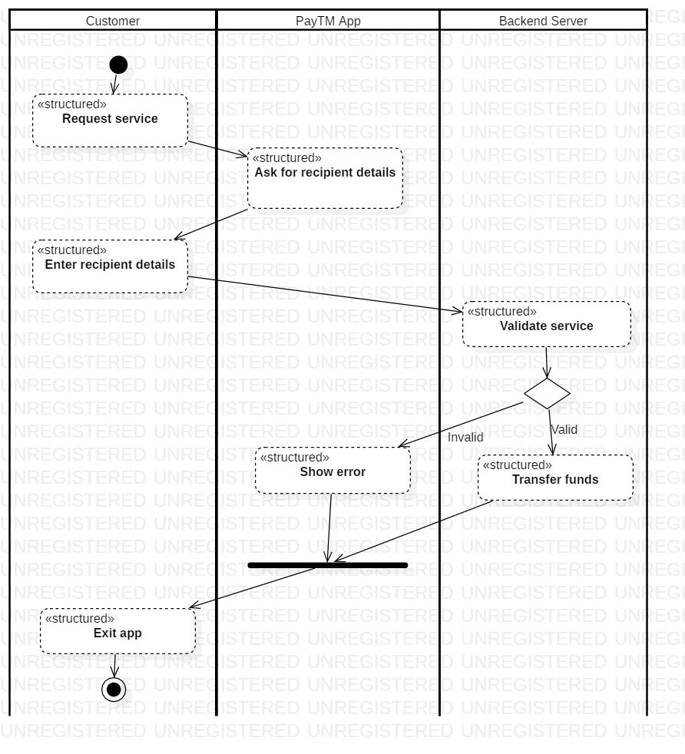

- Component Diagram
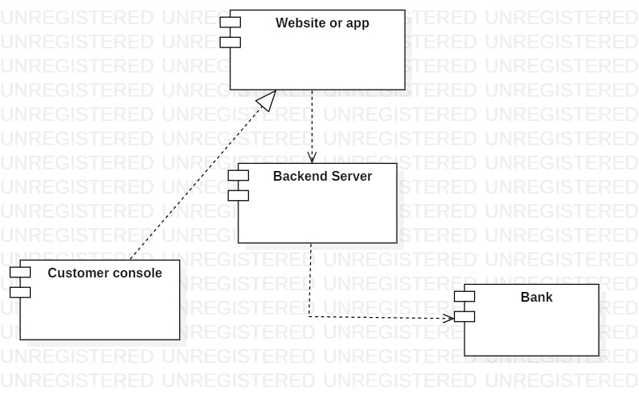
- Deployment Diagram
